Lab #4: Biscayne Bay Fish ID (handout)

Common name: great barracuda  Scientific name: Sphyraena barracuda  Family: Sphyraenidae | 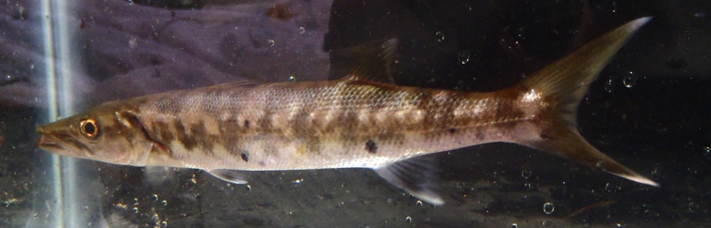  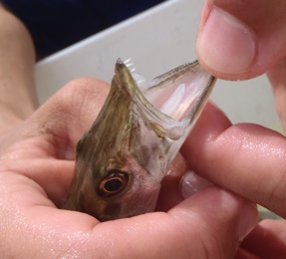
Common name: needlefish  Family: Belonidae  Note: two species pictured here | 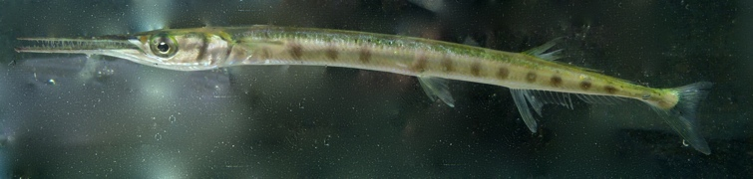  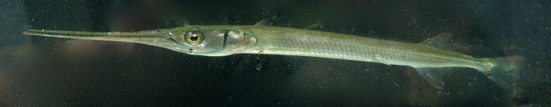
Common name: crested pipefish  Scientific name: Cosmocampus brachycephalus  Family: Sygnathidae | 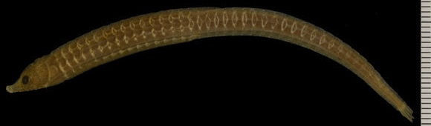
Common name: dwarf seahorse  Scientific name: Hippocampus zosterae  Family: Sygnathidae | 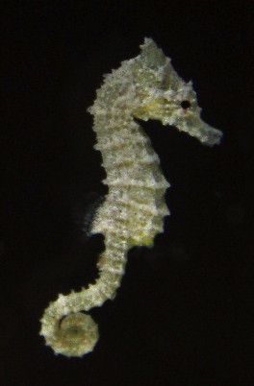
Common name: lane snapper  Scientific name: Lutjanus synagris  Family: Lutjanidae | 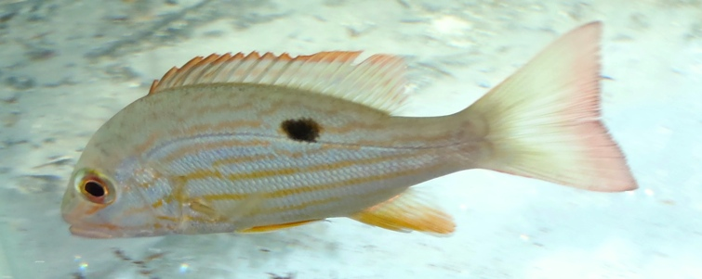
Common name: schoolmaster  Scientific name: Lutjanus apodus  Family: Lutjanidae | 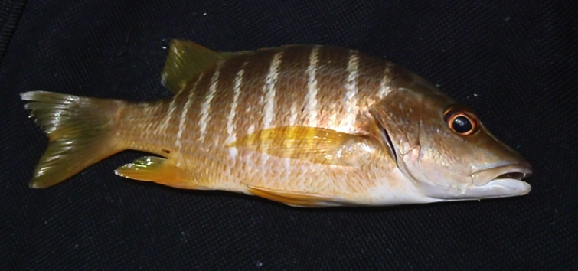
Common name: grunt  Family: Haemulidae  Note: multiple species pictured, two lower images are of juveniles. | 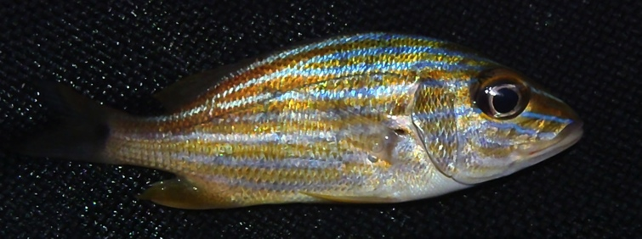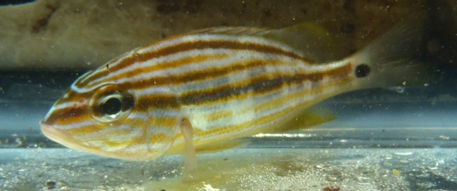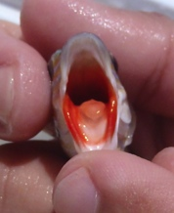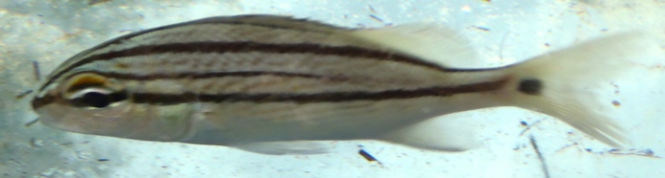
Common name: mojarra  Family: Gerreidae  Note: multiple species pictures, sizes are not the same | 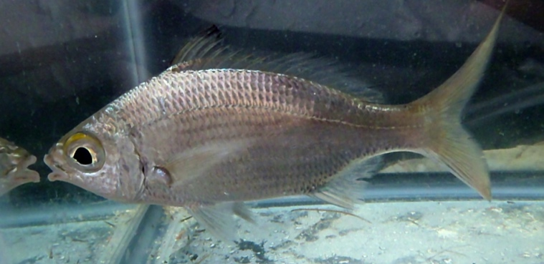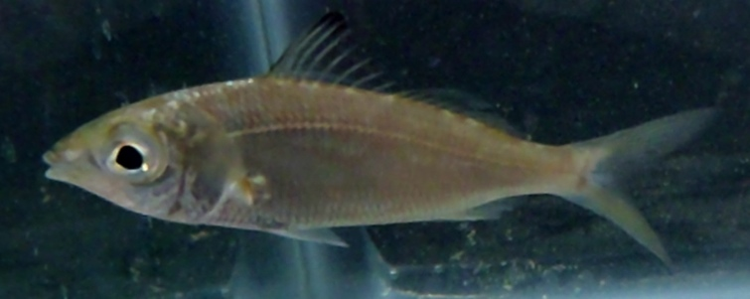  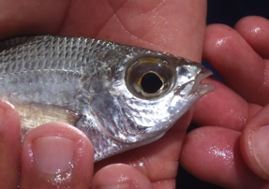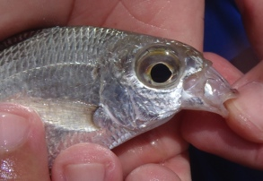
Common name: permit  Scientific name: Trachinotus falcatus  Family: Carangidae | 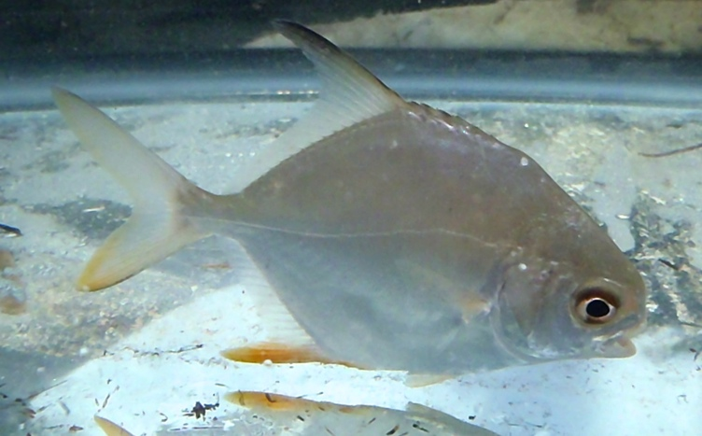
Common name: parrotfish (juvenile)  Family: Scaridae | 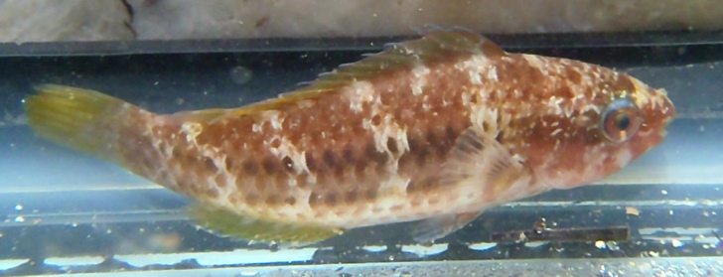
Common name: checkered puffer  Scientific name: Sphoeroides testudineus  Family: Tetraodontidae | 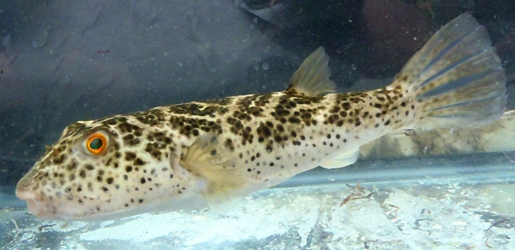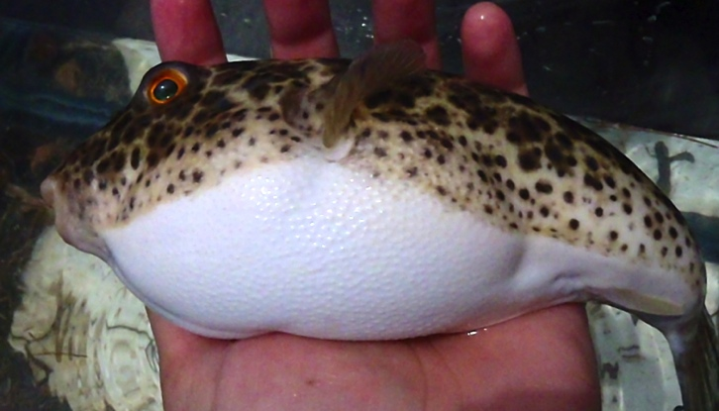
Common name: spotted scorpionfish  Scientific name: Scorpaena plumieri  Family: Scorpaenidae  Note: this species is venomous! | 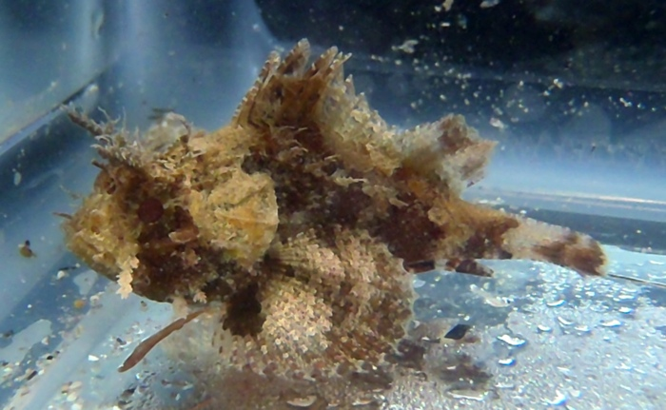
Common name: yellow stingray  Scientific name: Urobatis jamaicensis  Family: Urotrygonidae | 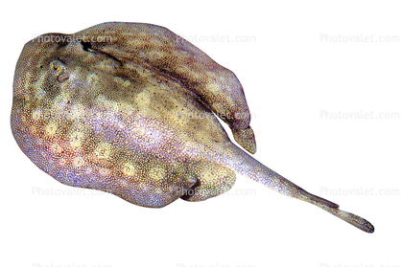
Common name: planehead filefish  Scientific name: Stephanolepis hispidus  Family: Monacanthidae | 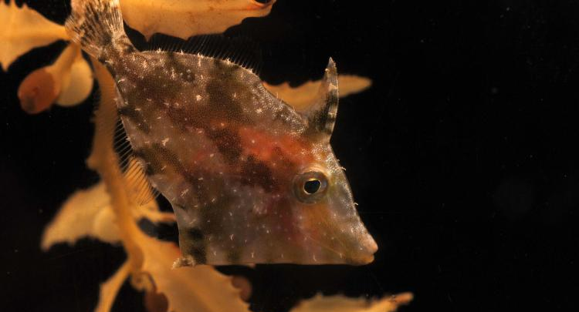
Common name: herring  Family: Clupeidae | 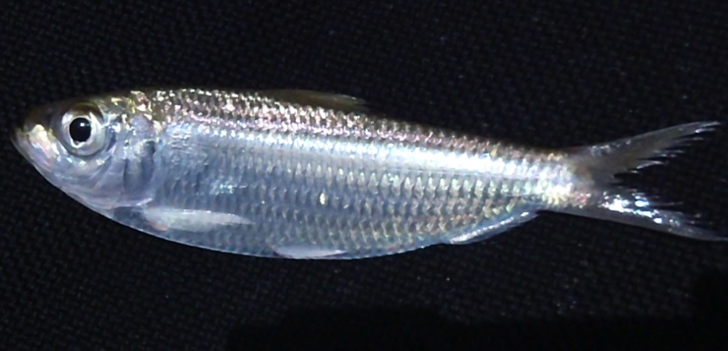
Common name: anchovy  Family: Engraulidae | 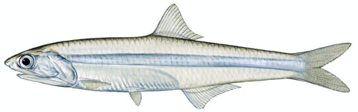
Common name: silverside  Family: Atherinopsidae | 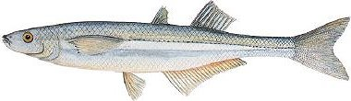
Common name: white mullet  Scientific name: Mugil curema  Family: Mugilidae | 

