Florida’s Coral Reefs

Florida is the only state in the continental United States to have extensive shallow coral reef formations near its coasts. Coral reefs create specialized habitats that provide shelter, food and breeding sites for numerous plants and animals, including spiny lobster, snapper and other commercial and recreational species. Coral reefs lay the foundation of a dynamic ecosystem with tremendous biodiversity. The Florida Reef Tract (FRT) stretches 358 miles from the Dry Tortugas National Park off of the Florida Keys to the St. Lucie Inlet in Martin County. Roughly two thirds of the Florida Reef Tract lies within the Florida Keys National Marine Sanctuary (FKNMS), a marine protected area that surrounds the Florida Keys island chain. The reefs stretching north of the FKNMS are managed by the Florida Department of Environmental Protection's (DEP) Coral Reef Conservation Program (CRCP) and the Southeast Florida Coral Reef Initiative (SEFCRI), which is one of several programs administered by the CRCP.

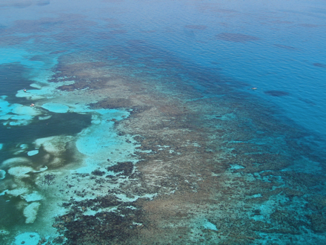
Florida's coral reefs came into existence 5,000 to 7,000 years ago when sea levels rose following the last Ice Age. Reef growth is relatively slow; an individual colony may grow one-half inch to 7 inches a year, depending on the species. All coral reefs are in a constant state of flux. While expanding with new polyps (the living tissue) on the outer surface, they are simultaneously being ground into sand by storms and animals. During long periods of favorable conditions, the reefs may reach awe-inspiring heights and diversity.
Aerial view of Carysfort Reef off of Key Largo, FL. Photo: Amy Massey

Different reef organisms characterize the type of habitats found along Florida reefs, typically transitioning from a cover of algae and small octocorals nearshore to numerous octocorals and varied hard coral populations at the outer reefs. The various reef architectural and compositional components create an environment that is ecologically diverse and productive, one that supports many other aquatic plants and animals that make southeast Florida reefs their home.

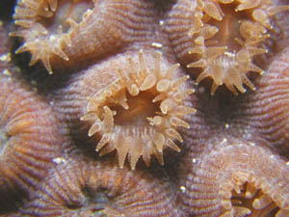
Corals are classified as animals, yet microscopic plants live within the animal tissues in a symbiotic relationship. The coral animals benefit from the sugars and oxygen that the plants provide through photosynthesis and the plants gain nutrients from animal waste and are protected within the coral tissues. These tiny plants give the coral much of its color.

Coral reef development occurs only in areas with specific environmental characteristics: a solid structure for attachment, relatively warm water temperatures, clear waters low in phosphate and nitrogen nutrients, and moderate wave action to disperse wastes and bring oxygen and plankton to the reef. Most of Florida's sport fish species and many other marine animals spend significant parts of their lives around coral reefs.
Close-up detail of coral polyps on a great star coral (Montastrea cavernosa) Photo: Dave Gilliam, National Coral Reef Institute

Types of Reefs and Corals
The three major types of coral reefs around the world are atolls, fringing reefs and barrier reefs. Florida's coral reef system most closely resembles a barrier reef, however, the reefs are closer to shore and they lack the shallow inshore lagoons found on most barrier reefs so it is more aptly named a bank reef. Florida also has patch reefs, which grow between the reef tract and the land in shallower waters. Patch reefs are typically small (the size of your back yard or a small home).

More than 45 species of stony corals and 37 species of octocorals are found along the Florida Reef Tract. Each kind lives in a separate colony that is shaped differently. The colonies take on the various hues of the algae that live within them. Corals can generally be divided into two main categories: stony corals and octocorals (sea fans and other soft corals). Marine sponges are also very important within the coral reef community and over 70 species can be found along the Florida Reef Tract.

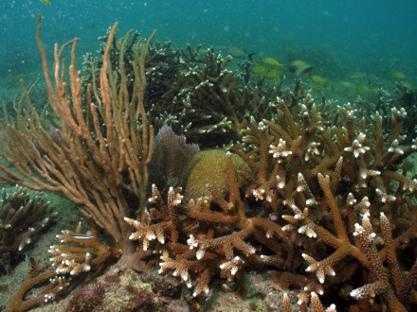
Stony corals are the major reef architects. Polyps, the living portion of corals, extract calcium from seawater and combine it with carbon dioxide to construct the elaborate limestone skeletons that form the reef backbone. Florida's most common reef-building corals are brain, star, elkhorn and staghorn. Brain coral is dome-shaped and has the waves, folds and ridges that resemble those of a human brain. Star coral is also dome-shaped, but has a distinctive star pattern on its surface that is caused by the accordion-like folds within its polyp cups. Elkhorn and staghorn corals are so named because their branchlike projections resemble the antlers of those animals. In recent years, corals have experienced declines due to a combination of factors, including coral disease and damage from hurricanes. In 2006, elkhorn and staghorn coral were listed as threatened species under the Endangered Species Act. To restore these corals that were once so abundant, coral nurseries have become established along Florida's coast and in the Florida Keys. Nurseries are growing new colonies and successfully out-planting them to locations where they had once flourished.
Staghorn corals off of Broward Couty. Photo: Dave Gilliam, National Coral Reef Institute

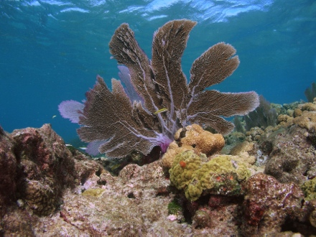
Octocorals, some of which are also called gorgonians, look like strange trees and shrubs, although they too are composed of living polyps. Unlike stony corals, octocorals are unable to build thick limestone skeletons, but are supported by an internal structure composed of a horn-like substance called gorgonin. The most common octocorals in Florida are sea fans and sea whips. Sea fans are pale lavender or green fan-shaped corals. Their fans flutter in the ocean current like lace curtains. Sea whips have long feathery branches that spread in all directions. They can be orange, lilac, purple, yellow, brown or buff.
Sea fan. Photo: Jeff Anderson, FKNMS

http://www.dep.state.fl.us/coastal/habitats/coral/
Biscayne National Park
Biscayne National Park consists of four primary ecosystems:
- a narrow fringe of mangrove forest along the mainland shoreline
- the southern expanse of Biscayne Bay
- the northernmost islands of the Florida Keys
- The beginning of the third-largest coral reef in the world
Each of these ecosystems is comprised of a variety of smaller communities like seagrass meadows, hardbottom areas and hardwood hammocks. The geology of the area has been influenced by changing sea levels, currents, hurricanes, and reef-building organisms like corals. South Florida's subtropical climate produces forest types that are more typical of the Caribbean than of mainland North America.
Mangroves
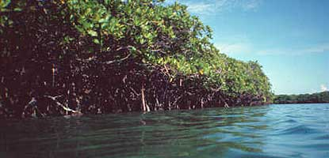
The word mangrove is used to describe several trees, not closely related to one another, that flourish in salty environments. Some have the ability to block absorption of salt at their roots while others secrete excess salt through their leaves, allowing them to thrive where other trees would die.

These mangroves, with their impenetrable root system, help to keep Biscayne's waters clean and clear by slowing the water that flows into the bay from the land, allowing the sediment carried by the runoff to settle out. These roots also provide shelter and protection for a host of marine organisms, especially the very young and small, while the trees branches above provide breeding and nesting areas for many birds, including the brown pelican.
Leaves fall from the mangrove's branches all year round. These leaves break down to become food for many marine organisms which, in turn, become food for larger organisms including commercially important species of fish, pink shrimp, and the Florida spiny lobster. Without healthy mangrove forests, Florida's vital recreational and commercial fisheries would drastically decline.
Three types of mangroves live in the park, not only along the mainland shoreline, but fringing the park's islands as well. In the textbook situation, starting from the water and working inland, you will find red, black, then white mangroves.

Biscayne Bay
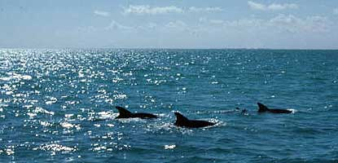
Biscayne Bay is a shallow estuary, a place where freshwater from the land mixes with salt water from the sea and life abounds. It serves as a nursery where infant and juvenile marine life reside. Lush seagrass beds provide hiding places and food for a vast array of sea life. In fact approximately 70 percent of the area's recreationally and commercially important fishes, crustaceans, and shellfish spend a portion of their young lives in the bay's protective environment.
Protected from the ocean to the east by a chain of islands or keys and by the mainland to the west, the bay is one of the most productive ecosystems in the park. Fresh water flow brings nutrients from inland areas. Plants use these nutrients, along with energy from the sun, carbon dioxide, and water to produce food through photosynthesis.

Florida Keys
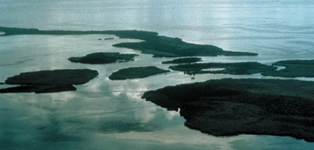
Looking across the bay, they appear as a string of emeralds lying along the eastern horizon. As you move closer, they rise out of the azure waters and reveal themselves as a chain of subtropical isles. Together they anchor the northern end of the coral rock Florida Keys and transition to the sand barrier islands of the north.
Elliott Key, the park's largest island, is considered the first of the true Florida Keys. The Keys are the remains of coral reefs which formed when ocean waters were much higher than they are now. Walking the island today, you can see the remains of the coral, even identifying the types of coral that you are treading on. The islands to the north of Elliott Key, from Sands Key to Soldier Key, are considered "transitional" islands – sharing some of the features of the hard rock coral keys to the south and some with the sand barrier islands to the north. Together, these islands provide a protective barrier between the ocean to the east, and the shallow waters of Biscayne Bay to the west.

Coral Reefs
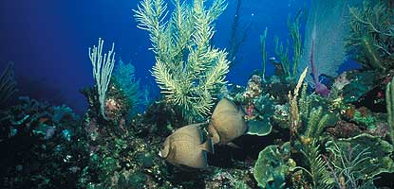
Tiny coral animals, called polyps, obtain calcium from seawater and use it to manufacture cup-like limestone skeletons around themselves. Generations of polyps creating adjoining cups result in fantastically shaped colonies that take on the appearance of flowers, mountains, and animal antlers. When colonies of various species occur in close proximity, they create the living fortresses we call reefs.

Stony corals aren't the only reef dwellers though. Sea whips, sea fans, and other soft corals sway back and forth in the current, giving the whole reef the appearance of movement. Bright sponges feed by filtering small plants and animals from seawater. Christmas tree worms burrow directly into the stony coral skeletons, adding tufts of red, orange, and purple to the grooved surface of brain corals. Algae and other plants growing in and around the reef provide an important food source for fish, shrimp, crabs, and a myriad of other animals.

For most people though, it is the fish that give reefs their magical qualities. Over 200 species of fish can be spotted on Biscayne's reefs. The diversity of colors, shapes, sizes, and behaviors is amazing. Inch-long damselfish nip at a diver's facemask, attempting to chase her away from its carefully tended algae garden. A green moray hovers, mouth agape, at the entrance to its lair. A variety of fish wait their turn at a "cleaning station," where tiny gobies scour their bodies for parasites. A stoplight parrotfish chomps on coral, devouring algae, polyps, and stone in one bite. A 500-pound goliath grouper peers out from under a ledge. A pair of spotfin butterfly fish float effortlessly through the water.

Coral reefs are among the most biologically diverse ecosystems on earth. Every crack and crevice seems to be occupied by something. As a result, human knowledge of the reef is constantly growing – a fact that should prove valuable as coral reefs around the world experience problems from pollution, overfishing, boat groundings, and disease. Florida's reefs are the world's most accessible, just a few miles by automobile from millions of residents and tourists. For this reason, they are also among the world's most vulnerable reefs. When diving, snorkeling, or boating, keep the following in mind:
- Do not stand on, sit on, break, or touch corals. The tiny polyps are fragile and easily damaged by even the gentlest touch.
- Always be aware of where your feet are. In your excitement to share your discoveries with others, you could be hitting the reef with your fins.
- When boating, use a chart to avoid running aground.
- Use mooring buoys where available. When anchoring a vessel, ensure the anchor is firmly set in sandy areas, not in coral.

By following these simple guidelines, you can ensure that your visit to the reef leaves no trace, visitors in 2077 will still see it the way Ralph Munroe did in 1877.

http://www.nps.gov/bisc/naturescience/index.htm

