Lab #1: Thinking Like a Scientist & the Scientific Method (Handout)

Thinking Like A Scientist

Science is the process of having or gaining knowledge and a scientist is a person who explores problems and answers questions about the natural world in search of that knowledge. Scientists are those people that have a natural curiosity in asking questions that no one has thought of before, are open-minded to accept new and different ideas, are creative in finding new ways to solve problems and possess an amount of skepticism from which they doubt ideas until they are fully tested. This laboratory class is necessary in your broad academic training because science is an integral part of our society. In marine biology we use the scientific process to acquire knowledge that is then used by politicians, housing developers, community activists, and other members of society in their endeavors. We hope that your exposure to the basics of marine biology will make you better informed in your professional life with regard to how you view science, and in your personal life to help you make informed voting decisions and relate to the marine environment. An important idea to remember about science is not everything is known about the universe. Science is a discipline that attempts to increase our knowledge by attempting to find answers to questions formed through observations.

Observation: gather information using your five senses: sight, smell, sound, touch, taste
Inferences: an interpretation or explanation based on your observations and prior knowledge
(not always correct but always based on reasoning from observed facts)
Prediction: make a forecast about a future event based on current evidence and past experiences

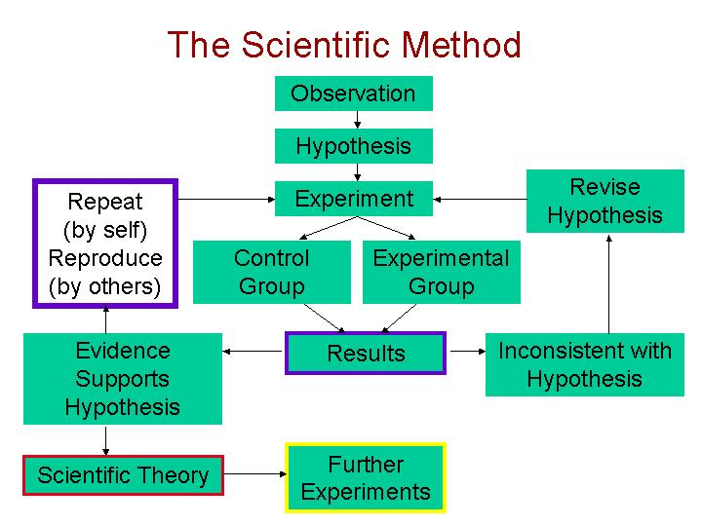

The Scientific Method

Questions form the basis of the scientific process because they enable us to solve problems that range from defining a term to understanding why a particular process occurs. There is a specific process for this approach:

- Develop a question (in our case about marine organisms).
- Determine how to approach the problem a question addresses with at least one hypothesis, which is a possible explanation to our question. These are typically formed after researching the topic.
- Then determine how you will answer your question to see whether your hypothesis is supported or rejected (we never prove a hypothesis from a single experimental procedure, we support it). The series of steps of how this is tested needs to be precise so that your colleagues can repeat your experiment in the future. This is part of the experimental procedure.
- You should obtain results from your experimental procedure, which are your data.
- You need to interpret your results to see whether or not they support or disprove your hypothesis. If the data support your hypothesis, then the hypothesis can be provisionally accepted (subject to further testing). If the data do not support your hypothesis, then reject the hypothesis. This is your conclusion.

In science we sometimes find that we do not get the results we thought we would. The benefit of going through the scientific process is that it enables us to ask more questions about a system as we develop a better understanding of cells, tissues, organisms, and ecosystems.

A Note on Variability in Data

Many of you will learn more about data analysis as you take more math and statistics courses. We use data to support or reject our hypothesis in the scientific process. There can be a lot of variation in the range of data. For example most of the class could be short and the 6 feet 5 inches person could really stick out. To get a better understanding of what is happening in the data set we like to look at the average (or mean) of the class. This is adding all their heights (data values) and dividing that sum by the number of students (sample size). We also like to have an idea of the standard deviation. This is a measurement of how much the set of values within a sample are different from the average. This allows us to know if most students’ heights are grouped around the average. Most reliable data sets have values that are clustered near the average. Scientists use statistics to determine the significance of any differences they find in their data set, from treatments to controls. These statistics are important in reporting data and the hypothesized effects of treatments on the organisms they are measuring.

