IDS 3214L - Lab 4

## Part A - USING THE MICROSCOPE

Microscopes are tools used to examine specimens too small to be observed with the naked eye. There are two major types of microscopes that you will use in this lab, compound light and dissecting microscopes. In general, a compound light microscope is used to visualize very small items (e.g. blood cells) while a dissecting microscope is used for observing much larger items (e.g. mouthparts of a grasshopper).

**A. Familiarize yourself with the use of the light microscope**

1. Identify each part labeled on the compound microscope in Figure 3 and note its function in Table 5:

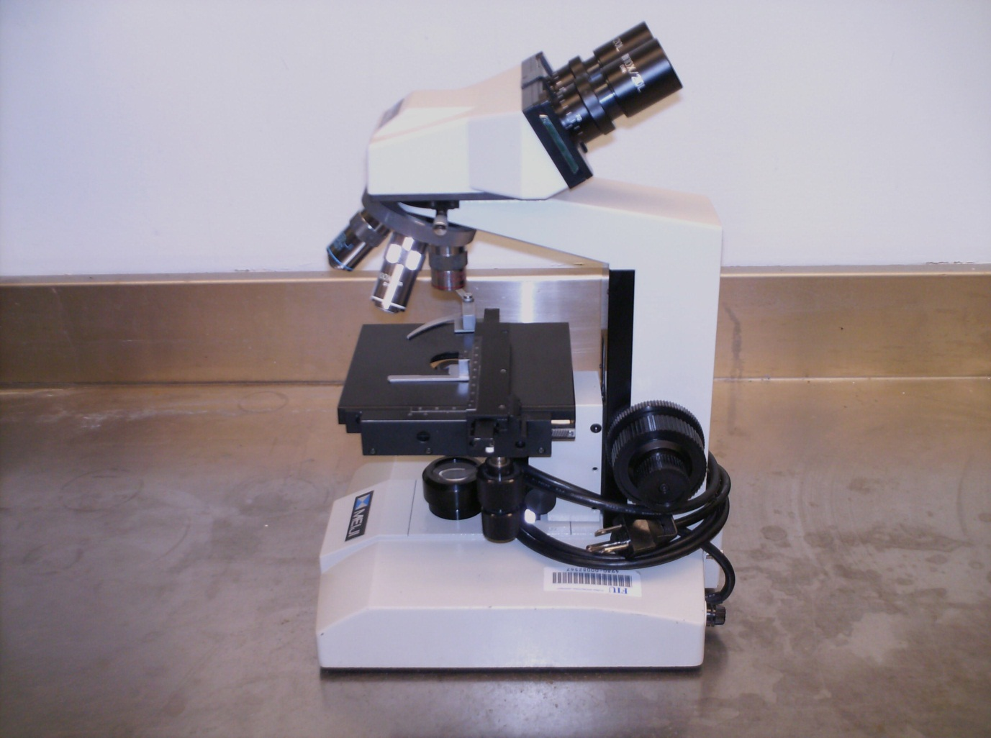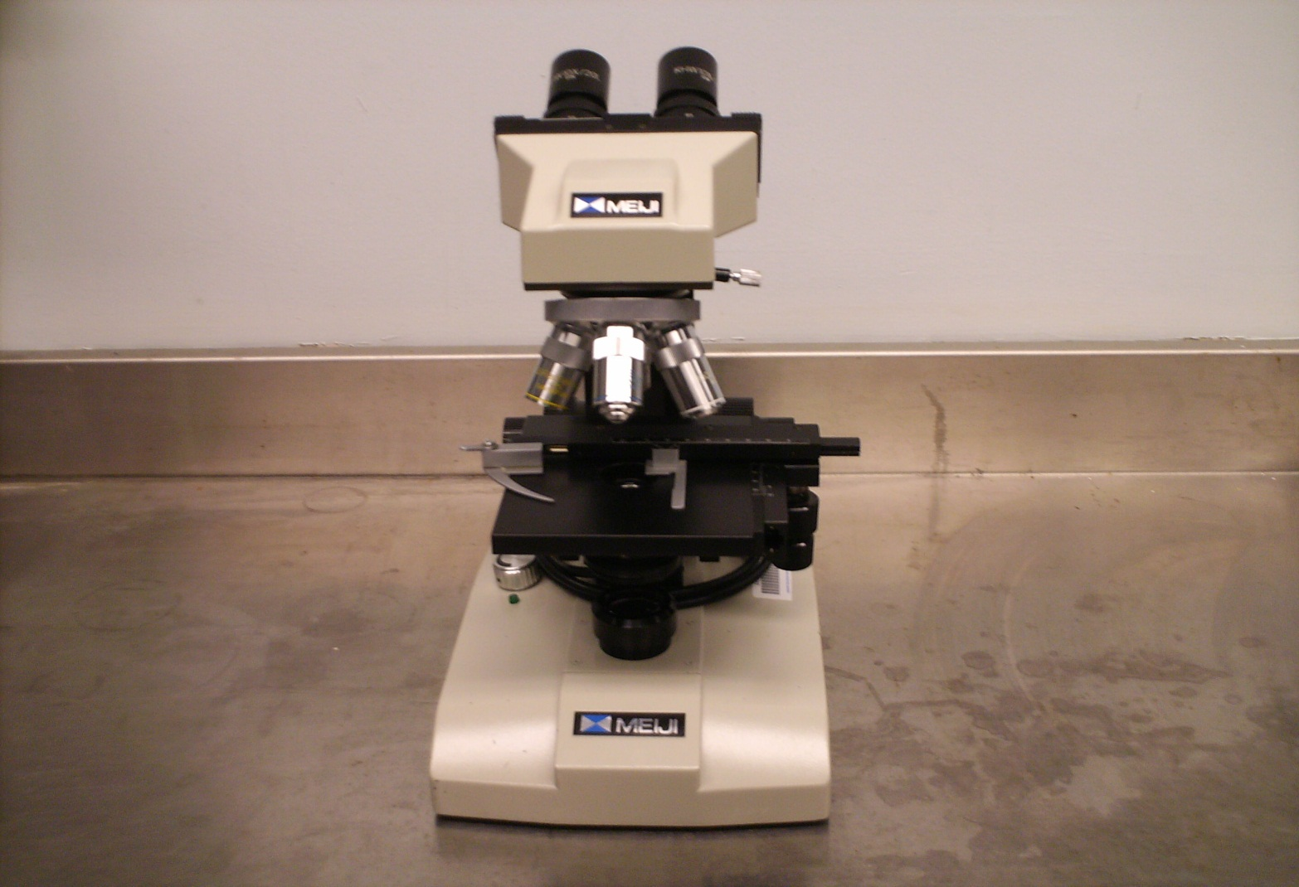

Oculars

Arm

Coarse Focus

Adjustment

Fine Focus

Adjustment

Stage

Base

Nosepiece

Condenser iris diaphragm

Field Iris

Diaphragm

Body Tube

Slide Holder

Objective

Stage Clip

Substage

Lamp

Figure 3. Major parts of a compound light microscope

**Table 5:**

|  |  |
| --- | --- |
| **Part** | **Function** |
| Objective |  |
| Stage Clip |  |
| Stage |  |
| Condenser Iris Diaphragm |  |
| Substage Lamp |  |
| Base |  |
| Oculars |  |
| Arm |  |
| Slide Holder |  |
| Coarse Focus Adjustment |  |
| Fine Focus Adjustment |  |
| Field Iris Diaphragm |  |

1. Plug in your microscope and turn the light source on. Rotate the objective lens to the 4X power. It should click into place. Note: You should always start at the lowest power available on a microscope

**Question**:

Why do you think it is best to always start at the low power objective?

1. Locate the coarse adjustment. Turn it while watching the stage. See how fast or slow it allows you to move the stage compared with the fine adjustment.
2. Adjust the ocular lenses so that they fit the width between your eyes. You will know the width is correct when you see one bright circle of light rather than two.
3. Binocular microscopes and stereomicroscopes have one ocular lens that is adjustable (see photograph below). This enables you to adjust the viewing for your eyes so that you do not need to wear your glasses. Remove your glasses before doing the procedure below.

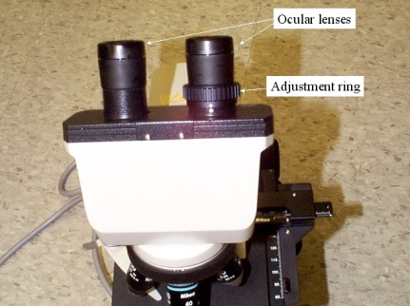

1. To adjust these lenses, first, cover the adjustable lens (or your eye) so that you cannot see the image through it. Next, focus the microscope the way you normally would so that a sharp image is produced through the ocular lens. Cover this lens (or eye) and view the image through the other (adjustable) ocular. Turn the ocular lens but not the focus knob and adjust so that the image is sharp.
2. Obtain the letter **e** slide from your slide box and place it on the stage (make sure it is held by the clip). Move the stage back and forth (left and right, forward or backward) so that the **e** is directly beneath the objective lens.
3. Looking through the oculars, move the coarse adjustment until you can see the **e** through the lens.
4. Use the fine adjustment to get the **e** into sharp focus.
5. Move the **e** left and right. And then forward and backwards.
6. Change the objective lens to 10X. **Note:** You should use the fine focus adjustment when working with the higher objective lens.

**Questions**:

* 1. As you view the letter **e**, how is it oriented? Upside down or right side up? What does that tell you about how the microscope processes the image?
  2. How does the image move when the slide is moved to the left or right?
  3. What happens to the brightness of the view when you switch from the 4X to the 10X objective?

**B. Magnification**

1. Examine your microscope and determine the magnification of each objective and for the oculars. Record this information in Table 6:

**Table 6:**

|  |  |  |  |  |
| --- | --- | --- | --- | --- |
| **Objective Magnification** | **Ocular Magnification** | **Total Magnification** | **FOV Diameter (mm)** | **FOV Area (mm2)** |
|  |  |  |  |  |
|  |  |  |  |  |
|  |  |  |  |  |

1. Calculate the total magnification (objective magnification x ocular magnification) for each objective and record in the table above.

**C. Field of View**

The field of view is the area you can see when you look through the lens of a microscope (Fig. 4). Understanding the size of this field under different magnifications is important because it allows you to be able to estimate the size of objects in your view. The following procedure demonstrates the determination of field of view (FOV) under various magnifications.

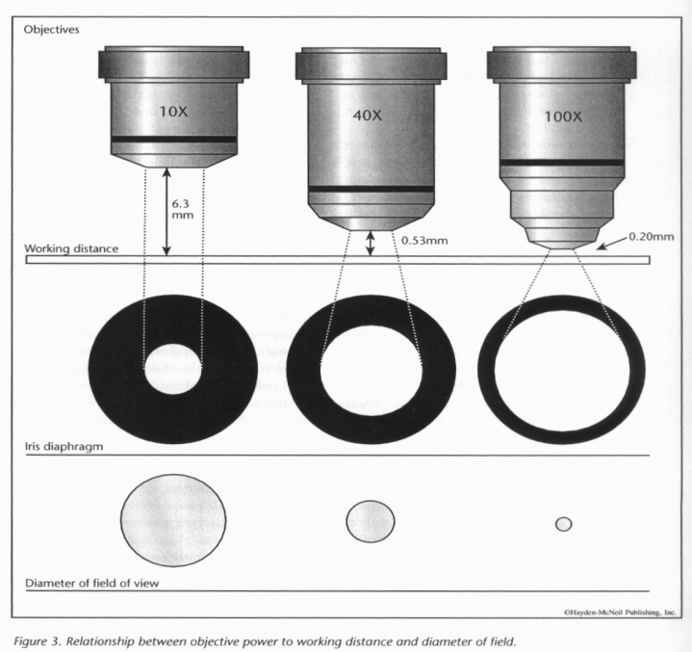

Figure 4. Field of view (FOV) under various magnifications

**Procedure:**

1. Place a ruler (mm) on the stage of the microscope.
2. Begin with the lowest power objective.
3. Using the coarse adjustment, get the ruler into focus. Only use the fine adjustment to sharpen the image. Measure the diameter of the field of view and record this in your Table 9.
4. FOV can easily be determined for the low power. At higher powers, you will not be able to use the ruler because the field of view is too small (see Fig. 6). Instead, you can use the following formulas:

FOVlow x Maglow = FOVmedium x Magmedium

Or

FOVlow x Maglow = FOVhigh x Maghigh

Use these formulas above to calculate the FOV at medium power (10X objective) and at high power (40X objective). Record your results in the Table 6.

1. Area of a circle = π x radius2. Use this formula to calculate the area of the FOV for each magnification and record your results in Table 6. Remember, you measured/calculated the FOV diameter, not the radius (½ diameter).

**Questions**:

1. Discuss the advantage and limitation of viewing specimens under highest magnification.
2. What about the low-power objective?
3. Which magnification provides the largest FOV? Which provides the smallest?

**D. DEPTH OF FIELD**

Thedepth of field is the thickness of the object being viewed with a microscope.

1. Place the colored thread slide on the stage of your microscope.
2. Start by using the lowest power objective lens. Use the coarse adjustment to get the threads into focus. Sharpen the image with the fine adjustment knob. Try to determine how many threads are present by focusing up and down. Once the number of threads is known, determine what order they are in (i.e., which is on the bottom, the middle and then top).
3. Repeat this process using the high power objective lens.

**Questions**:

1. How does depth of field affect viewing biological phenomena that are thick?
2. Are all three threads visible under the low power? Can they all be seen at the same time under higher power?
3. Which objective provides the greatest depth of field?

**E. Preparing Wet Mounts of Biological** **Specimens**

1. Place a drop of “pond water” on a clean slide. Position the edge of a coverslip against the water drop (at a 45o angle) and then slowly lower the coverslip onto the slide. This is called a wet mount.
2. Once prepared, view the slide with your microscope. Try to locate any micro- or macro-organisms present on your slide and draw these in the space provided. Take note of the tips on the next page as you begin to look for organisms. The drawings will not be judged based on artistic ability, but it is important that you can create an accurate representation of what you see. In future labs you will be asked to make drawing of specimens, which will help you in studying for quizzes and exams. For each task requiring the use of blank slides and cover slips for the remainder of the semester, your group will be responsible for cleaning, drying, and putting away all slides and cover slips so that they can be used later in the lab or by the students in the next lab section.

|  |
| --- |
| **Magnification: _________** |

**MICROSCOPE TIPS:**

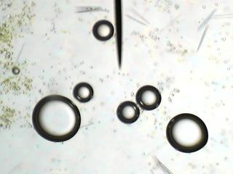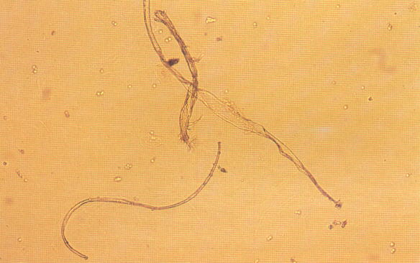

This is an air bubble, NOT your specimenThese are cotton fibers, not your specimen

**F. Dissecting Microscope**

1. Obtain one dissecting microscope for your table.
2. Familiarize yourself with all the parts of the microscope labeled in Figure 7.

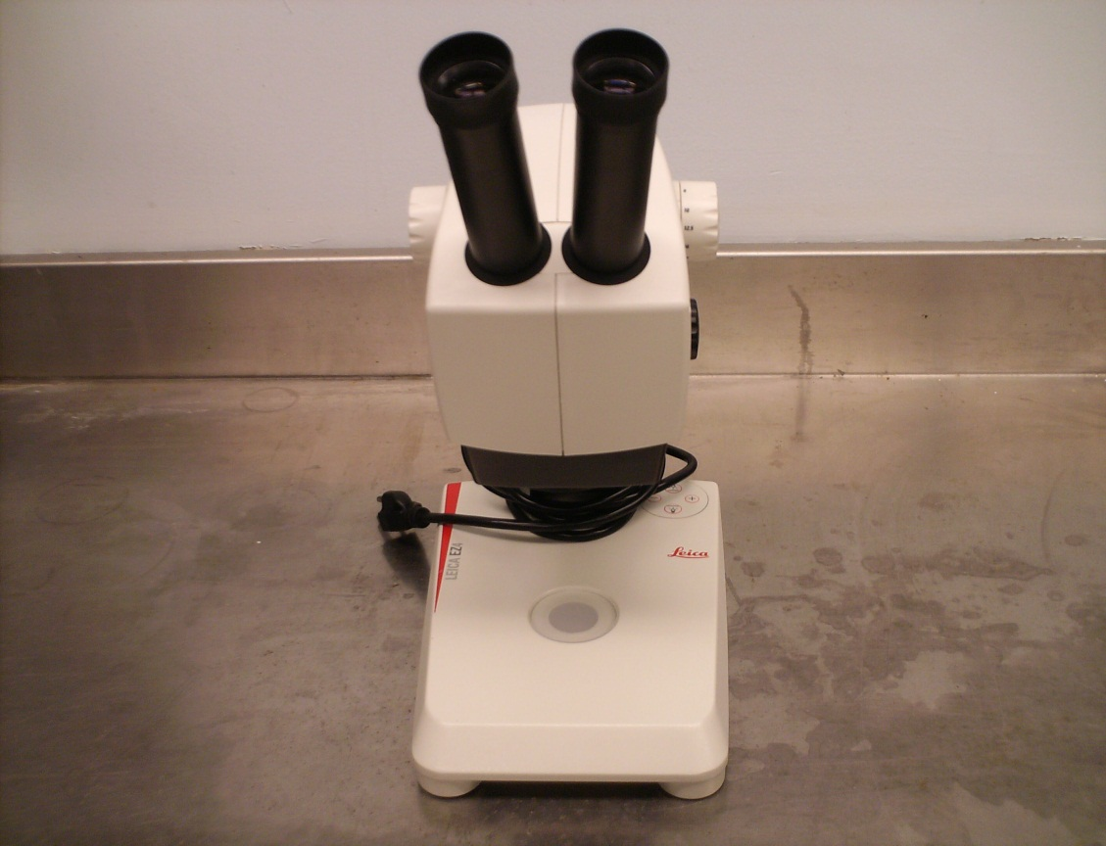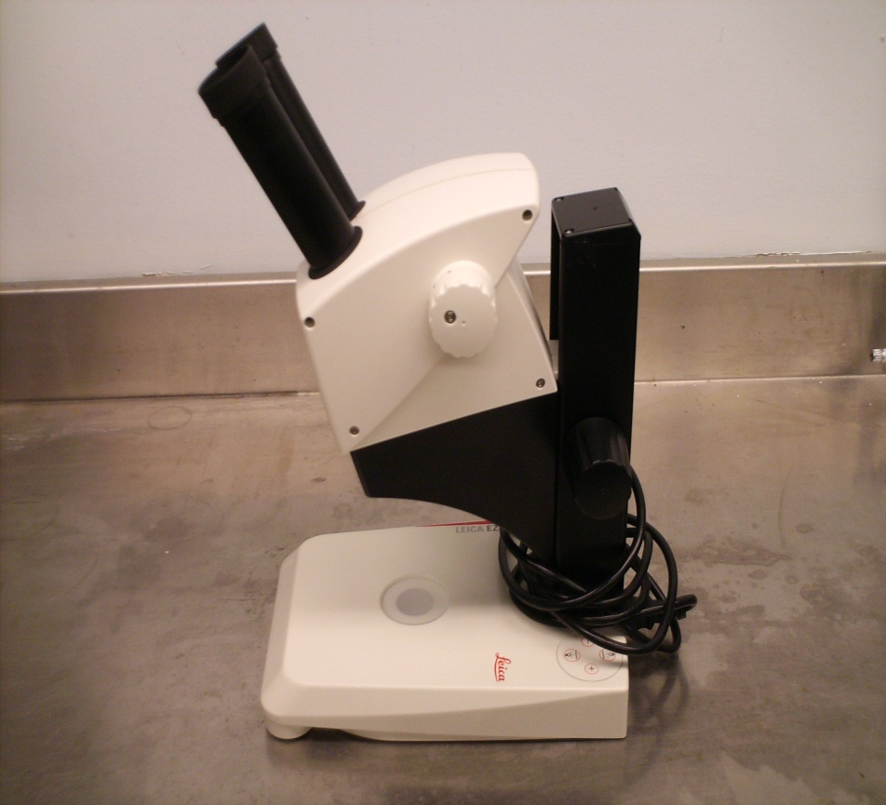

Focus

Adjustment

Arm

Transmitted Light Source

Stage

Ocular Lens

Base

Zoom

Magnification Adjustment

Figure 7. Major parts of a dissecting microscope

1. Plug in the scope and turn on the two light sources. One source provides light from below and the other from above.
2. Add a small amount of “pond water” to a weigh boat or a petri dish and examine it under the dissecting microscope. Sketch some of the organisms that you see in the space provided.

|  |
| --- |
| **Magnification: ________** |

1. Use a ruler to measure the FOV diameter at the lowest and the highest magnification.

FOV diameter low power = _____________

FOV diameter high power = _____________

1. Now calculate the FOV area for both magnifications.

FOV area low power = _____________

FOV area high power = _____________

1. Looking through the lens, move the Petri dish containing the “pond water” backwards and forwards, then left and right. Is the direction noted through the lens the same as when observed with the naked eye?
2. Place the letter **e** slide on the stage. How is it oriented when you look through the lens compared to when you examine it with the naked eye?

**G. Comparison of Compound and Dissecting Microscopes**

Compare the two types of microscopes we examined today in Table 10.

**Table 10:**

|  |  |  |
| --- | --- | --- |
| **Characteristic** | **Dissecting Microscope** | **Light Microscope** |
| Magnification |  |  |
| Resolution |  |  |
| Size of field of view |  |  |
| Depth of field |  |  |
|  |

## Part B – Identifying Algae

**INTRODUCTION TO ALGAE**

Algae are part of a group of organisms called protists. This group is comprised of all eukaryotic organisms that lack the features of animals, plants, and fungi. Therefore, while protists do have similar characteristics in some instances (they are generally found in moist environments and are usually microscopic), there can be considerable differences between them. The current classification of protists divides this group into several supergroups, each of which display distinct features, and share several characteristics with plants, animals, or fungi.

In addition to phylogenetic similarities, species are assigned to supergroups based on their ecological roles: algae are generally autotrophic, protozoa are free ranging heterotrophs, and slime molds are decomposers like fungi. Algae most resemble plants, because they are autotrophic and have a variety of pigments used to convert light energy to chemical energy via photosynthesis. **They are an important component of aquatic ecosystems globally - producing a major component of the world’s oxygen and serving as an important food source for many different animals in lower trophic levels.**

The major groups of algae are distinguished in part by their energy storage products, cell walls, and color resulting from the type and abundance of colored pigments (Table 2). Algae are also distinguished by their cellular organization. Unicellular algal species occur as single, unattached cells that may or may not be motile. Filamentous algal species occur as chains of cells attached end to end. These filaments may be few to many cells long and may be unbranched or branched in various patterns. Colonial algae occur as groups of cells attached to each other in a nonfilamentous manner. For example, a colony may include several to many cells adhering to each other as a sphere, flat sheet, or other three-dimensional shape.

**GREEN ALGAE (*Chlorophyta*)**

Green algae are the most diverse and familiar algae in freshwater, however a few genera live in marine ecosystems. Green algae share several characteristics with plants, including chlorophylla a and b, starch as the main storage material, and cell walls made of cellulose, but green algae are protists, not plants.

Today we are going to examine and compare the general structure of different green algae. We will mainly look at Volvox and Spirogyra. *Spirogyra* is one of the most common filamentous green algae, and is typically found in freshwater ecosystems. *Volvox* consists of many cells bound in a common spherical matrix. Each cell in the sphere has two flagella extending outward from the surface of the colony, and synchronized beating of the flagella spins the colony through the water like a globe on an axis. In addition to coordinated movement, cells within the colony can be functionally different, and a few select cells aid in reproduction through the production of eggs and sperm.

Green algae exhibit considerable variability in their structure, and in addition to structural complexity, green algae also use different forms of reproduction based on the species. Some species such as *Chlamydomonas* generally reproduces asexually through mitosis, but are not restricted to only reproducing in this fashion, while *Spirogyra* reproduces sexually through conjugation, and *Volvox* reproduces sexually through oogamy.

During conjugation (reproductive process) in *Spyrogyra*, filaments of opposite mating types lie side by side and form projections that grow toward each other. These projections touch and the separating wall dissolves and forms a conjugation tube. The cellular contents of the - strain migrate through the conjugation tube and fuse with the nonmotile + strain. The zygote resulting from the fusion of gametes develops a thick, resistant cell wall and is termed a zygospore. The zygospore is released when the filament disintegrates, at which time the zygospore undergoes meiosis to form haploid cells that become new filaments.

Reproduction in *Volvox* is more complex, such that motile sperm swim and fuse with large motile eggs to form a diploid zygote. The zygote enlarges and develops into a thick-walled zygospore released when the parent colony disintegrates. The zygospore then undergoes meiosis to produce haploid cells that subsequently undergo mitosis and become a new colony. *Volvox* also reproduces asexually when some cells of the colony divide, bulge inward, and produce new colonies that are initially held within the parent colony.

**Procedure:**

1. Using the available prepared slides and live cultures, observe and record the differences between *Spirogyra and Volvox*.

**Questions:**

1. Are the filaments of *Spirogyra* branched? What is the arrangement of the chloroplasts of *Spirogyra*? What advantage(s) do these characteristics provide?
2. What are some potential methods of asexual reproduction for *Spirogyra*?
3. What are the notable differences and similarities between *Spirogyra* and *Volvox*?

_____________________________________________________________________________

**BROWN AND RED ALGAE (*Phaeophyta* and *Rhodophyta*, respectively)**

In comparison to green algae, which are most commonly found in freshwater, brown and red algae primarily exist in marine environments. These algae are also generally **multicellular**, larger in size, and more structurally complex than green algae. Brown algae usually grow in cool waters and get their name from the presence of a brown pigment call fucoxanthin, while red algae typically grow in warm waters and get their color from the presence of red phycoblinins. Species of brown and red algae may be attached to a substrate or free floating, and some species have special adaptations to increase energy efficiency in their respective environments. For example, *Macrocystis*, a large brown algae, can reach 100 meters in length with the base anchored at the substrate of the ocean floor, but the leaves float on the surface to optimize exposure to sunlight.

*Fucus* is a common genus of brown algae, and typically attaches to rocks in the intertidal zone. The outer surface is covered in a gelatinous sheath to prevent desication, and special structures serve as anchors to prevent the dislodgement of individuals. The tips of fucus branches may be swollen and contain the reproductive structures oogonia (female - produce eggs) and antheridia (male - produce sperm). Unlike many green algae, fucus undergoes meiosis and produces gametes, which fuse to form a zygote. Therefore, it does not exist in a multicellular haploid stage, and does not experience the alternation of generations (Fig. 1).

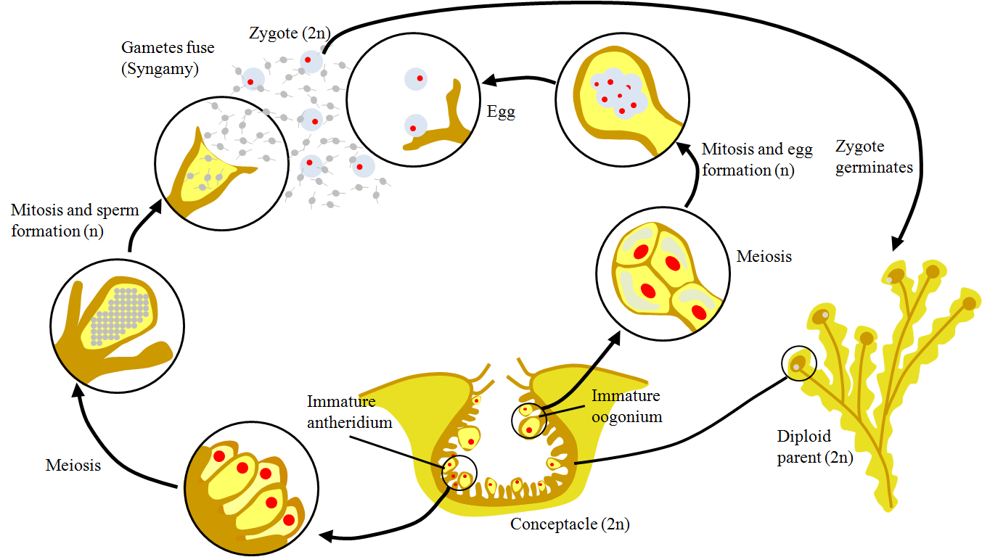

Figure 1: *Fucus* reproduction

In comparison, red algae experience alternation of generations, with multicellular haploid and diploid stages. An interesting difference that red algae exhibits, is that species within this group have no flagellated life cycle and lack motile sperm, and therefore fertilization relies upon water currents to the passively transport the male gametes to the female gametes.

**Procedure:**

1. Use your dissecting and compound light microscope to look at the structure of *Fucus*, *Polysiphonia*, and *Porphyra*. Note any structural differences between these algae (i.e. compare brown to red algae), and compare these algae to the species of green algae observed above.

**Questions:**

1. How does the structure of green, brown, and red algae differ? What are some commonalities?
2. Different pigments are responsible for the coloration of different algal species. Why would different algae have different pigments if they all acquire energy from the sun in order to photosynthesize and produce their own food?

**DIATOMS, DINOFLAGELLATES, AND EUGLENOIDS (*Bacillariophyta*, *Dinozoa*, and *Euglenida*, respectively)**

This last group of algae exhibits considerable differences from the previous groups, as well as many differences within the group. All of the algae in these groups are unicellular, but diatoms move passively through their environment based on currents, waves, and other physical disturbances; while dinoflagellates and euglenoids have two flagella with which they move through the water. Each represents the base of the food chain in their respective ecosystems, but also contributes to the environment in other ways.

Diatoms have a golden-brown color due to their xanthophyll pigments. Although they are small, diatoms are very abundant and rapidly reproduce, making them important components in marine systems. Diatoms have a hard cell wall made of silicon dioxide, and the cell walls persist long after the cell dies and the internal features disintegrate. As they fall through the water column, they accumulate in layers of diatomaceous earth that can be hundreds of meters deep, and provide a source of silicon in the water column.

Dinoflagellates actively move through their environment, and their flagella are located in distinct grooves along their cell walls, which are covered by cellulose plates. Similar to diatoms, dinoflagellates can reproduce rapidly, and when conditions are right, massive outbreaks can occur in marine waters and cause severe fish and invertebrate kills due to the production of toxins and the depletion of oxygen. Yet, these are important members of marine communities, and in addition to being free-living, some species live symbiotically with other organisms, like corals.

Euglenoids (Fig. 2) are generally found in freshwater, and unlike diatoms and dinoflagellates, their cell walls are made largely of protein, allowing the walls to be flexible. Unlike many alga species, euglenoids can adjust their mode of energy acquisition based on the environmental conditions experienced - euglenoids are typically autotrophic, but can absorb organic molecules from their surroundings (saprophytic), or engulf prey by phagocytosis (heterotrophic). Euglenoids also have a stigma/eyespot, with which they use to orient themselves in the water column

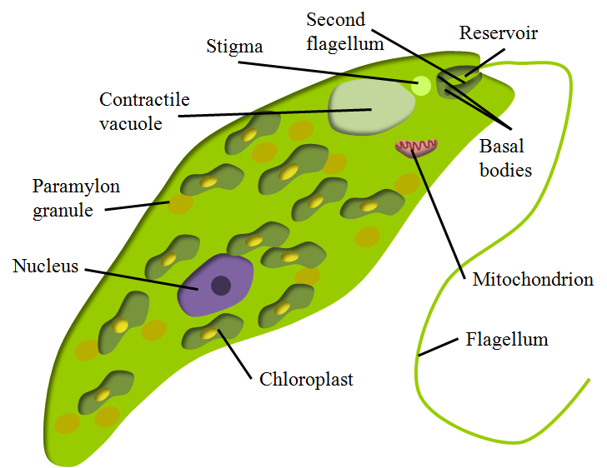

Figure 2: *Euglena* body plan

**Procedure:**

1. Using your compound light microscope, observe the prepared slides and live cultures of diatoms, dinoflagellates, and euglenoids. Note any structural differences between these algae, and compare these algae to the species of green algae observed above.