Pollution and Water Quality Lab

Introduction
What is water pollution?
Water pollution can be defined in many ways. Usually, it means one or more substances have built up in water to such an extent that they cause problems for animals or people.
The sources of water pollution are categorized as being a point source or a non-point source of pollution. Point sources of pollution occur when the polluting substance is emitted directly into the waterway. A pipe spewing toxic chemicals directly into a river is an example. Nonpoint source pollution comes from several diffuse sources; for example, runoff of pollutants, such as herbicides and fertilizers, from agricultural lands. There are different types of water pollution:
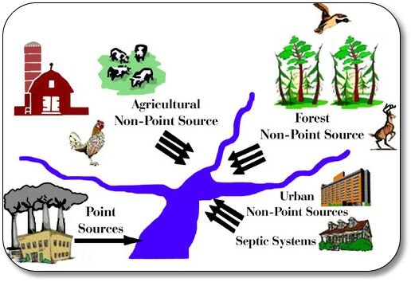
Image 1. Point and Nonpoint Source pollution (http://www.dwaf.gov.za/Groundwater/Groundwater_Dictionary/nonpoint.jpg)
1. Surface Water Pollution
Surface water pollution is the most visible form of pollution and we can see it floating on our waters in lakes, streams, and oceans. Trash from human consumption, such as water bottles, plastics and other waste products, is most often evident on water surfaces. This type of pollution also comes from oil spills and gasoline waste, which float on the surface and affect the water and its inhabitants.
2. Groundwater Pollution
This type of pollution is becoming more and more relevant because it affects our drinking water and the aquifers below the soil. Groundwater pollution is usually caused by highly toxic chemicals and pesticides from farming that leak through the ground to contaminate the wells and aquifers below the surface.
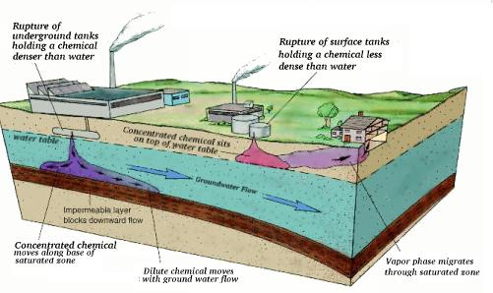
Image 2. Groundwater Pollution (http://earthsci.org/education/teacher/basicgeol/groundwa/groundwa.html#Factoriesandundergroundstorage)

3. Microbiological Pollution
Microbiological pollution is the natural form of water pollution that is caused by microorganisms in uncured water. Most of these organisms are harmless but some bacteria, viruses, and protozoa can cause serious diseases such as cholera and typhoid. This is a significant problem for people in third world countries who have no clean drinking water and/or facilities to treat the water.
4. Oxygen Depletion Pollution
Microorganisms that thrive in water feed on biodegradable substances. When there is an influx of biodegradable material from such things as waste or erosion from farming, the numbers of these microorganisms increase and utilize the obtainable oxygen. When these oxygen levels are depleted, harmless aerobic microorganisms die and anaerobic microorganisms thrive. Some of these organisms produce damaging toxins like sulfide and ammonia.
5. Nutrient Pollution
Nutrients are usually found in wastewater and fertilizers. These can cause excess vegetation in the water such as algae and weeds, using up the oxygen in the water and hurting the surrounding marine life and other organisms in the water.
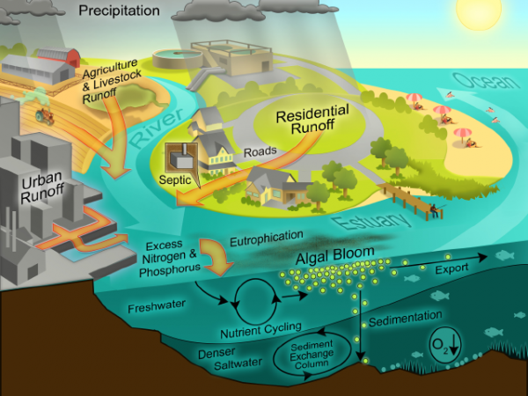
Image 2. Nutrient pollution (http://www.wri.org/files/wri/paerlFig7.png)
6. Suspended Matter Pollution
This type of pollution occurs when pollutants enter the water and do not mix in with the water molecules. These suspended particles form fine silt on the waterbed, harming the marine life by taking away the nutrients and disturbing their habitat.
7. Chemical Pollution
Due to the nature of industry these days and the mass production in industrial plants and farms, we have a lot of chemical run-off that flows into the nearby rivers and water sources. Metals and solvents flow out of factories and into the water, polluting the water and harming the wildlife. Pesticides from farms are like poison to the wildlife in the water and kill and endanger the aquatic life. If birds or humans eat these infected fish the toxins are transferred to us and we swallow these dangerous pesticides and toxins, affecting our health.
Petroleum is a different type of chemical pollutant that dramatically affects the aquatic life. This oil kills the fish and marine life and sticks to the feathers of birds, causing them to lose their ability to fly.

Determining Water Quality
In the early 1970s, the National Sanitation Foundation, in cooperation with over 100 water quality experts, devised a standard index for measuring water quality. This index, known as the Water Quality Index, or WQI, consists of nine tests to determine water quality. These nine tests are: temperature, pH, turbidity, total solids, dissolved oxygen, biochemical oxygen demand, phosphates, nitrate, and fecal coliform. A table (or graph) for each of the nine tests indicates the water quality value (or Q-value) corresponding to the data is obtained. Once the Q-value for a test has been determined, it is multiplied by a weighting factor. Each of the tests is weighted based on its relative importance to overall water quality. The resulting values for all nine tests are totaled and used to gauge the health of the water source (excellent, good, medium or average, fair, or poor).
In this experiment, you will be performing five core WQI tests: temperature change, dissolved oxygen, pH, total dissolved solids, and turbidity for the different campus sites (bay area, pond, mangroves). A modified version of NSF WQI Worksheet for these five tests will allow you to determine the general quality of the water source being sampled.
Procedure
- Walk to your designated site and using the GPS sensor locate 3 sampling areas that are at least 10 meters apart. Record the coordinates in your notebook.
- Connect the Dissolved Oxygen Probe to the interface and start the data-collection program. Allow the probe to stay in distilled water for at least 5 minutes as the probe warms up.
- Collect DO data at the 3 sampling areas and record the average.
- Place the tip of the probe into the water sample being tested. Submerge the probe tip to a depth of 4–6 cm.
- Start data collection. Gently stir the probe in the water sample. Note: It is important to keep stirring until you have finished collecting data.
- Continue stirring and data collection until the readings have been relatively stable (stable to the nearest 0.2 mg/L) for about 30 seconds, then stop data collection.
- Select the stable region of your graph, then display Statistics for that region. Note and record the mean value for that region as the DO of the water sample (in mg/L).
- Measure and record the temperature of the water sample at the 3 sampling areas, and take the average. Record the value (in ºC).
- Determine the percent saturation of DO for the water sample using your DO value from Step 3, the temperature you measured in Step 4, Tables 4 and 5 provided by your TA, and the formula
% saturation = (actual DO reading / Saturated DO reading from Table 4) X 100
- Use a Conductivity Probe to obtain the total dissolved solid (TDS) value for the water sample at the 3 chosen areas. Have the switch on the Conductivity Probe box set to 0–2000 µS/cm (2000 µS/cm = 1000 mg/L TDS). Record the values (in mg/L). Take the average and record in your notebook
- Use a pH Sensor to measure the pH of the water samples. Calculate and record the average value.
- Collect turbidity data.
- Connect a Turbidity Sensor to the interface. Allow the powered Turbidity Sensor to warm up for five minutes.
- Calibrate the sensor or manually enter calibration values following instructions from your teacher.
- Obtain a portion of slightly turbid water from your teacher. Fill your turbidity cuvette until the bottom of the meniscus is exactly at the top of the line on the cuvette. This sample level is critical to obtaining correct turbidity values.
- Measure the turbidity of the water samples. Take the average and record the value (in NTU).
- Once you are done collecting data, return to the lab and measure Water Quality Index for your sites using the WQI Worksheet and determine the quality of the water using the WQI Quality scale.

