**Worksheet Week 2.**

**Problem 1.** The graph of a function f is given below. Use the graph to answer the questions that follow

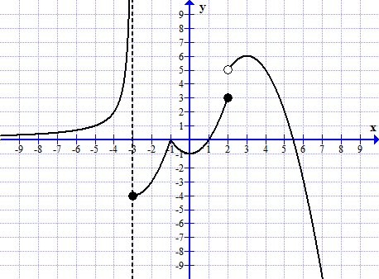

1. Find the following limits

  

  

  

1. What is the domain of this function?
2. What is f(-3)? What is f(2) ?

**Problem 2.** Compute each limit

  