**Worksheet Week 2.**

**Problem 1.** The graph of a function *f* is given below. Use the graph to find the limits below. Specify if a limit does not exist or is infinite.

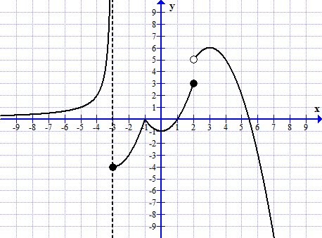

   

  

  

**Problem 2.** Sketch the graph of a function *y = f(x)*  which satisfies **all** of the following conditions:

(i) the domain of *f* is (0, +∞); (ii) *f(2) = f(4) = 0;*

(iii) ; (iv) ;

(v)  and ;

(vi)  3.

**Problem 3.** Compute each limit:

  