Determine the listed weather elements for each plotted station model. Omit elements not plotted. According to the longitude and latitude given, please determine the location of the station and the local time at the given UTC. Then please describe the current weather and speculate about the meteorological context. (16.7 pts each, total 100 pts)

surface station model**1. 25N, 80W, 18Z (1 pt for each blank)**

1. Wind speed_________________
2. Wind direction______________
3. Sky cover_________________
4. Temperature________________
5. Visibility___________________
6. Current weather______________
7. Dew point__________________
8. Low cloud type______________
9. Pressure tendency____________
10. Sea-level pressure____________
11. Middle cloud type____________
12. High cloud type______________

Location and local time (2pts):

Describe weather conditions (2.7 pts):

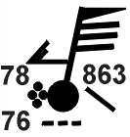**2. 25N, 80W, 00Z (1 pt for each blank)**

1. Wind speed_________________
2. Wind direction______________
3. Sky cover_________________
4. Temperature________________
5. Visibility___________________
6. Current weather______________
7. Dew point__________________
8. Low cloud type______________
9. Pressure tendency____________
10. Sea-level pressure____________
11. Middle cloud type____________
12. High cloud type______________

Location and local time (2pts):

Describe weather conditions (2.7 pts):

**3. 47S, 127E, 06Z (1 pt for each blank)**

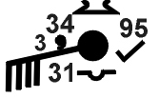

1. Wind speed_________________
2. Wind direction______________
3. Sky cover_________________
4. Temperature________________
5. Visibility___________________
6. Current weather______________
7. Dew point__________________
8. Low cloud type______________
9. Pressure tendency____________
10. Sea-level pressure____________
11. Middle cloud type____________
12. High cloud type______________

Location and local time (2pts):

Describe weather conditions (2.7 pts):

**4. 33N 112W, 21Z (1 pt for each blank)**

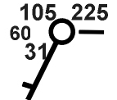

1. Wind speed_________________
2. Wind direction______________
3. Sky cover_________________
4. Temperature________________
5. Visibility___________________
6. Current weather______________
7. Dew point__________________
8. Low cloud type______________
9. Pressure tendency____________
10. Sea-level pressure____________
11. Middle cloud type____________
12. High cloud type______________

Location and local time (2pts):

Describe weather conditions (2.7 pts):

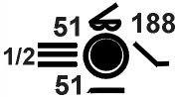

**5. 37N 122W, 12Z (1 pt for each blank)**

1. Wind speed_________________
2. Wind direction______________
3. Sky cover_________________
4. Temperature________________
5. Visibility___________________
6. Current weather______________
7. Dew point__________________
8. Low cloud type______________
9. Pressure tendency____________
10. Sea-level pressure____________
11. Middle cloud type____________
12. High cloud type______________

Location and local time (2pts):

Describe weather conditions (2.7 pts):

**6. 42N 95W, 18Z (1 pt for each blank)**

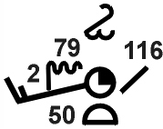

1. Wind speed_________________
2. Wind direction______________
3. Sky cover_________________
4. Temperature________________
5. Visibility___________________
6. Current weather______________
7. Dew point__________________
8. Low cloud type______________
9. Pressure tendency____________
10. Sea-level pressure____________
11. Middle cloud type____________
12. High cloud type______________

Location and local time (2pts):

Describe weather conditions (2.7 pts):